https://colab.research.google.com/drive/1bPywVHJA8tIyktHxvxA2BisZk9uTBhc1?usp=sharing

- How do resale prices vary across the U.S. states? - Youngseo
  - Which states have the highest resale value for the vehicles?

- Statistical Summary
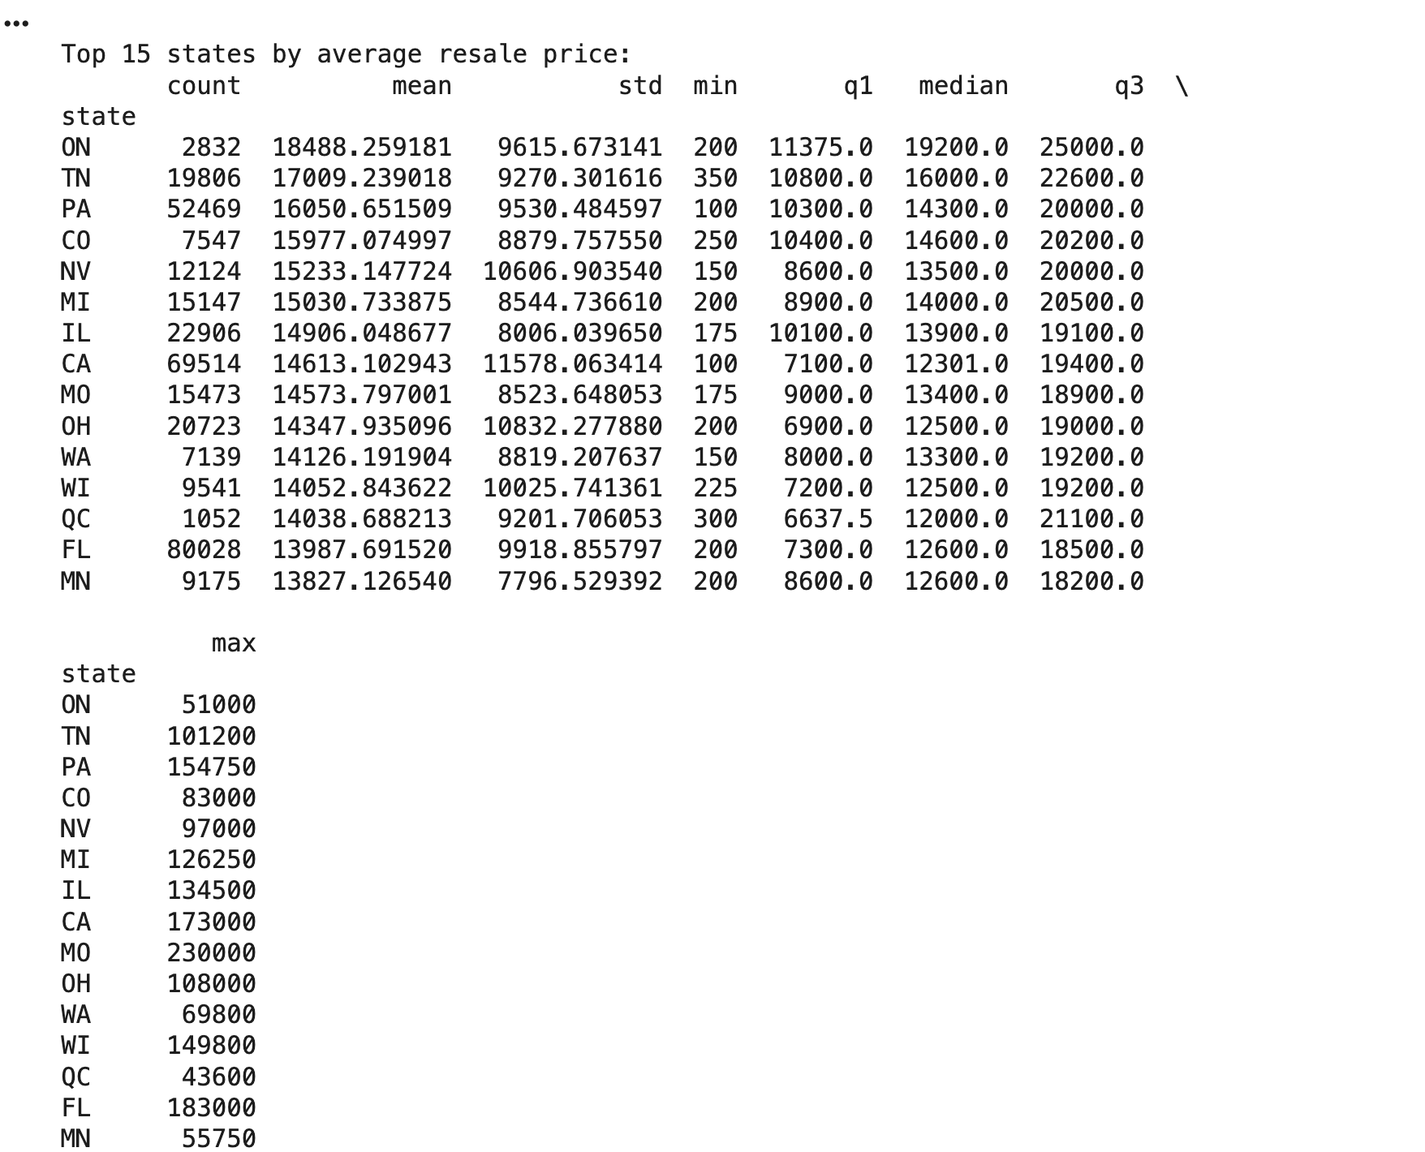
- The Top 15 States with the highest resale value 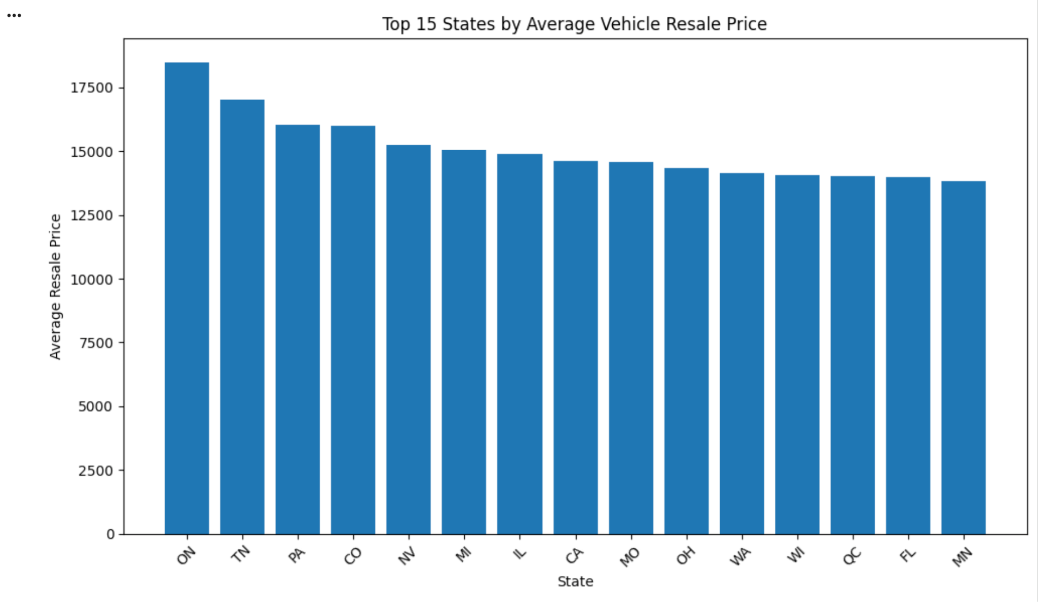(by the mean)
  - The distribution shown through the box plot 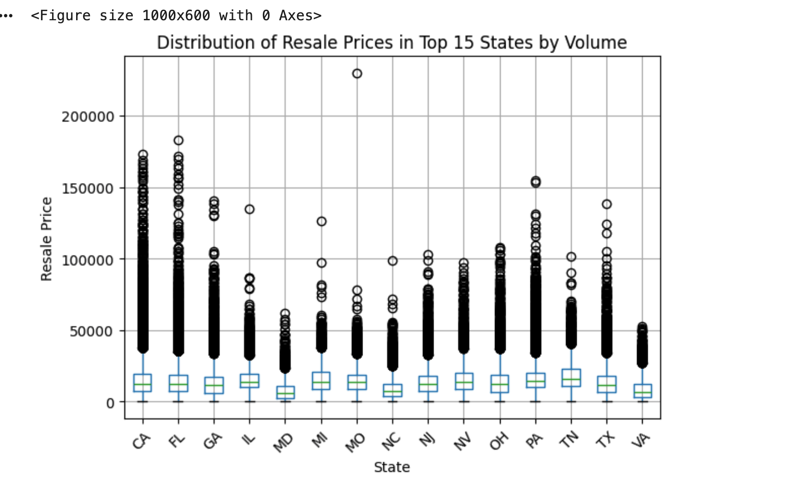
And then did the same for the top 5 -> and based on the statistical summary, the bar chart, and the box plot the top 5 states that have the highest average resale value are: TN, PA, CO, NV, MI
-> meaning that on average, the cars on these states keep their resale value more than other states

- > other questions we can do
- how does the resale value vary across the continents(region) -> east, west, mid ect
- pick a specific car model type and do the : a toyota camry , note the average milage because it affects the resale value of the car. Do what is the
-> join with the income and see if is it matches
Interpretation of Data and its Analysis
To compare resale prices across states, we cleaned the main dataset, standardized state codes, and kept only valid U.S. states. We then grouped transactions by state and calculated summary statistics for selling price, including the mean, median, standard deviation, and percentiles. Sorting states by mean resale price showed which state’s markets sit at the top of the distribution and which fall toward the bottom.
From this state-level table, we identified the top fifteen states by average resale price and then focused on the top five. In our sample, Tennessee, Pennsylvania, Colorado, Nevada, and Michigan have the highest average resale prices. In simple terms, vehicles sold in these states tend to transact at higher prices than vehicles sold elsewhere in the dataset.
We visualized these patterns using bar charts and box plots. The bar charts highlight the relative gaps in mean resale prices by state, while the box plots for the top states show that higher averages are not just driven by extreme outliers. Medians and interquartile ranges are also elevated, indicating that typical transaction prices are higher in these markets, not just the tails.
However, such comparisons are derived based on the average resale price for each state. A state’s resale value can be high, either because similar cars are valued higher there or because that state simply sells more high-priced vehicles (newer models, luxury brands, high-trim trucks, etc.). That said, because we have a large number of transactions per state, we expect some of these composition effects and extreme outliers to be partially normalized in the averages and medians.
Even with that limitation, the state-level patterns are strategically important. The fact that average resale prices differ systematically across states means geography should be a factor of consideration when making purchases. On the seller’s side, especially those operating across multiple states and pricing off a single national curve is likely underpricing inventory in higher-value states like Tennessee, Pennsylvania, Colorado, Nevada, and Michigan, while overpricing in lower-value states.
We believe that this analysis can be utilized as a first-layer signal in pricing and logistics. For example, a national dealer could selectively ship vehicles into higher-price states when the expected uplift in resale value exceeds transport and handling costs. Similarly, a marketplace or pricing tool could incorporate state-specific baselines so recommended list prices and trade-in offers reflect local market conditions rather than a generic national average.

